SIT120 - Introduction to Responsive Web Apps Week 1: Introduction to HTML, CSS

**List of Tasks:  
Pass Task 1 – Create an HTML Page**

Reflection:

This task helped me to understand HTML tags which are used to create web pages. I also learned different attribute properties of html elements to describe and structure the web page contents.

Below is the screenshot of simple web page & html code.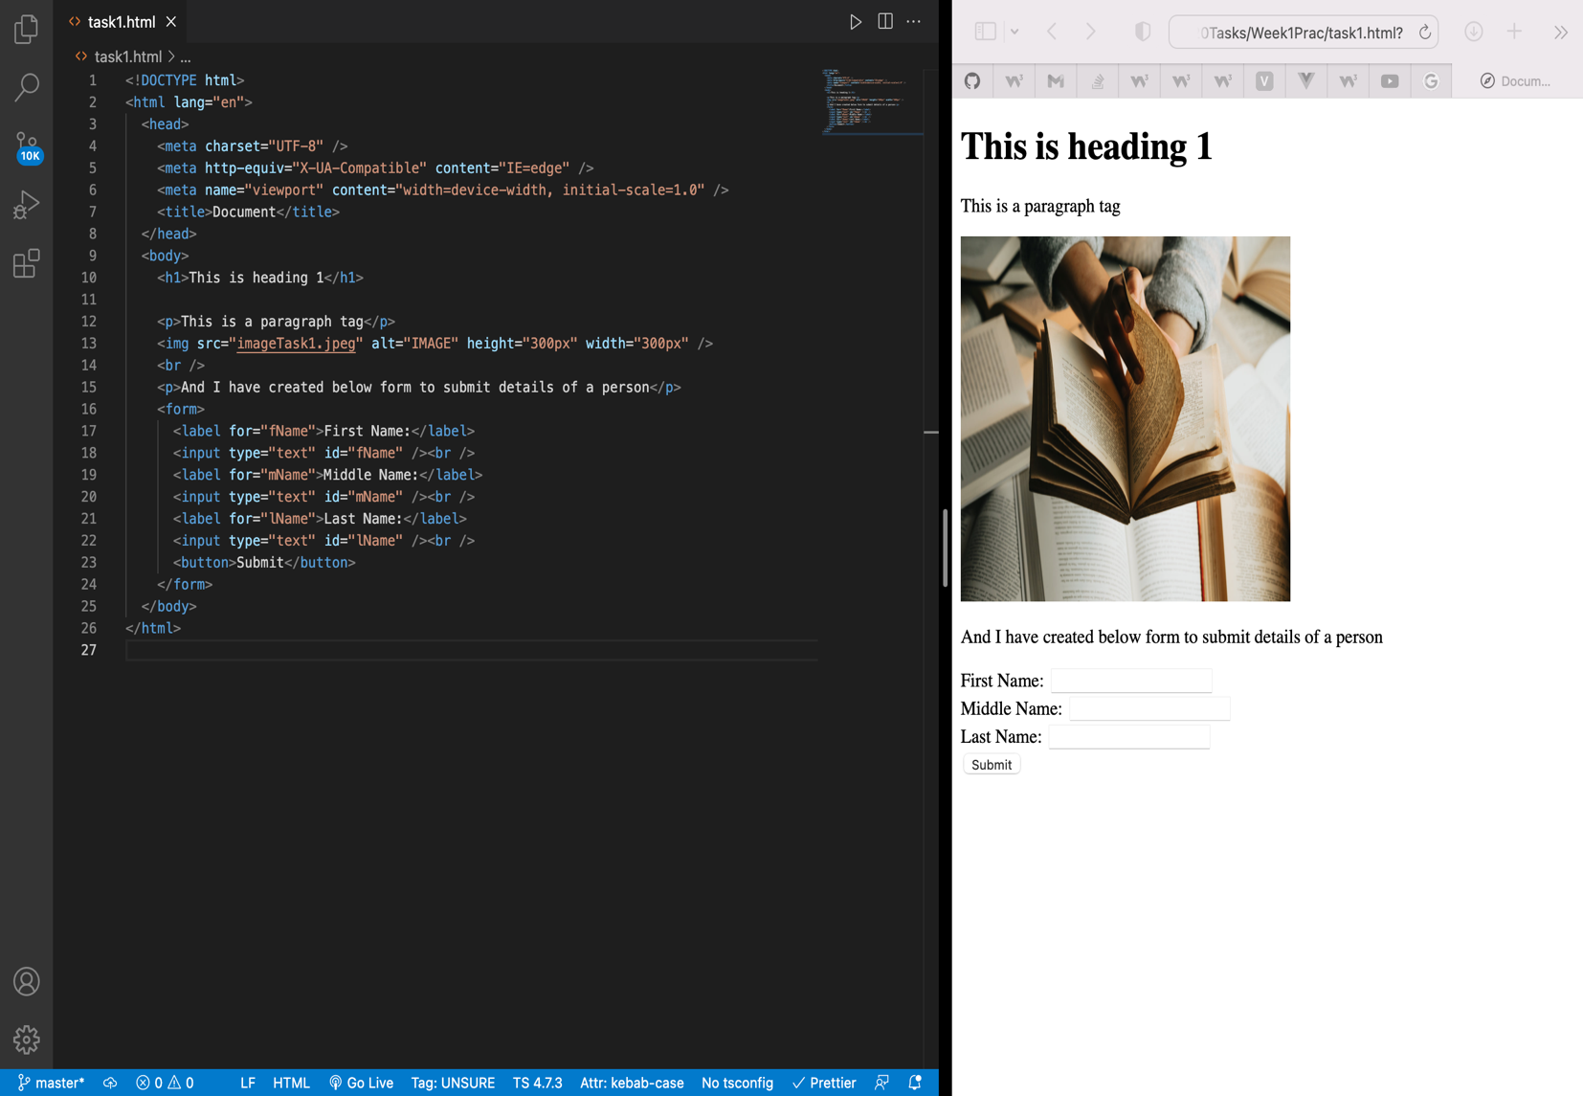

**Pass Task 2 – Add CSS to your HTML page**

Reflection:

This task help me to implement different styling properties of CSS to decorate the webpage. There three different ways to add CSS properties in html elements.

1. Inline
2. Internal
3. External

Below is a web page after implementation of CSS styling.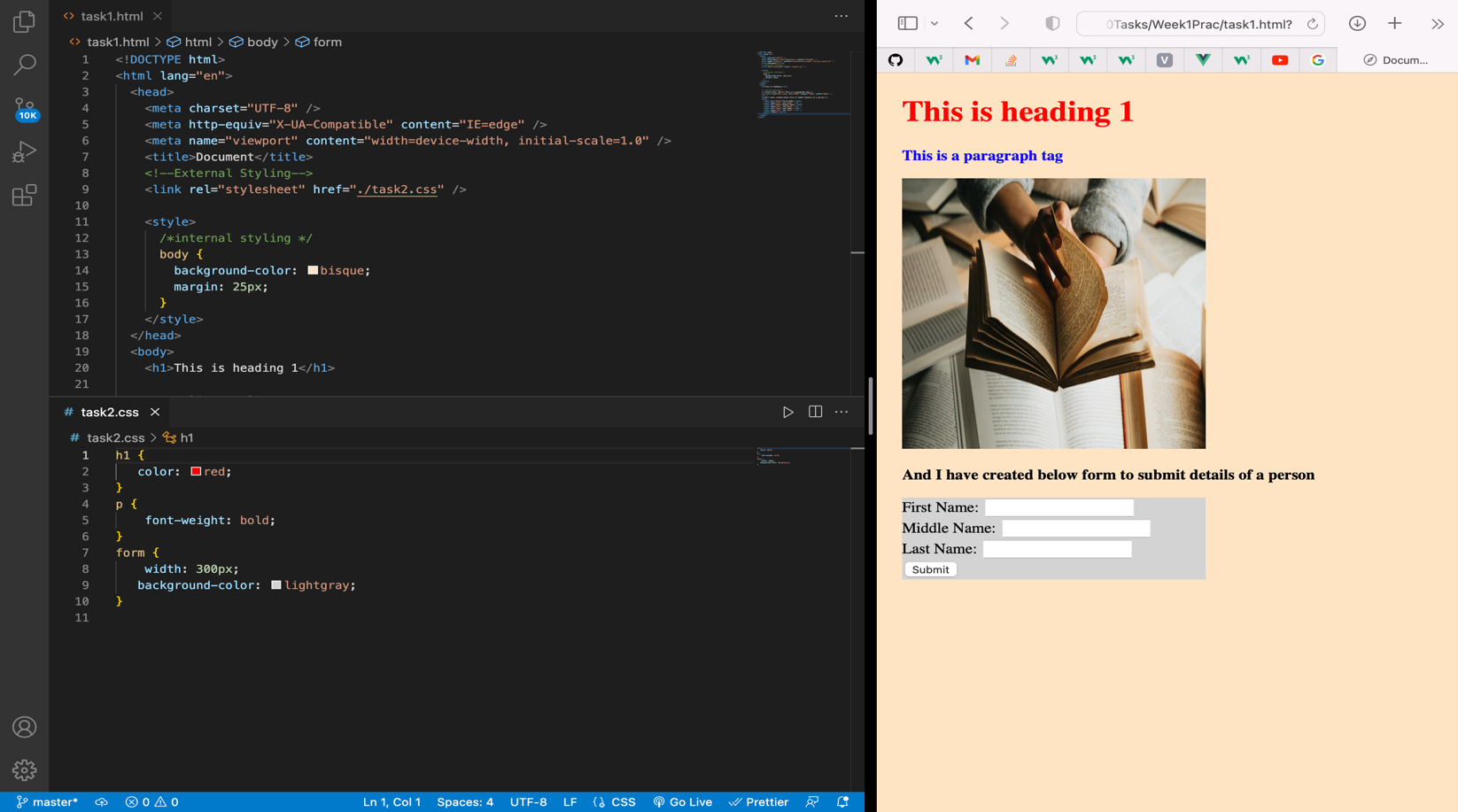

**Pass Task 3 – Adding JavaScript**

Reflection:

After completion of this task, I was able to adds functionality to the html elements using JavaScript.

Below webpage shows that if a user clicks the button “Current Date & Time” it displays current date & time

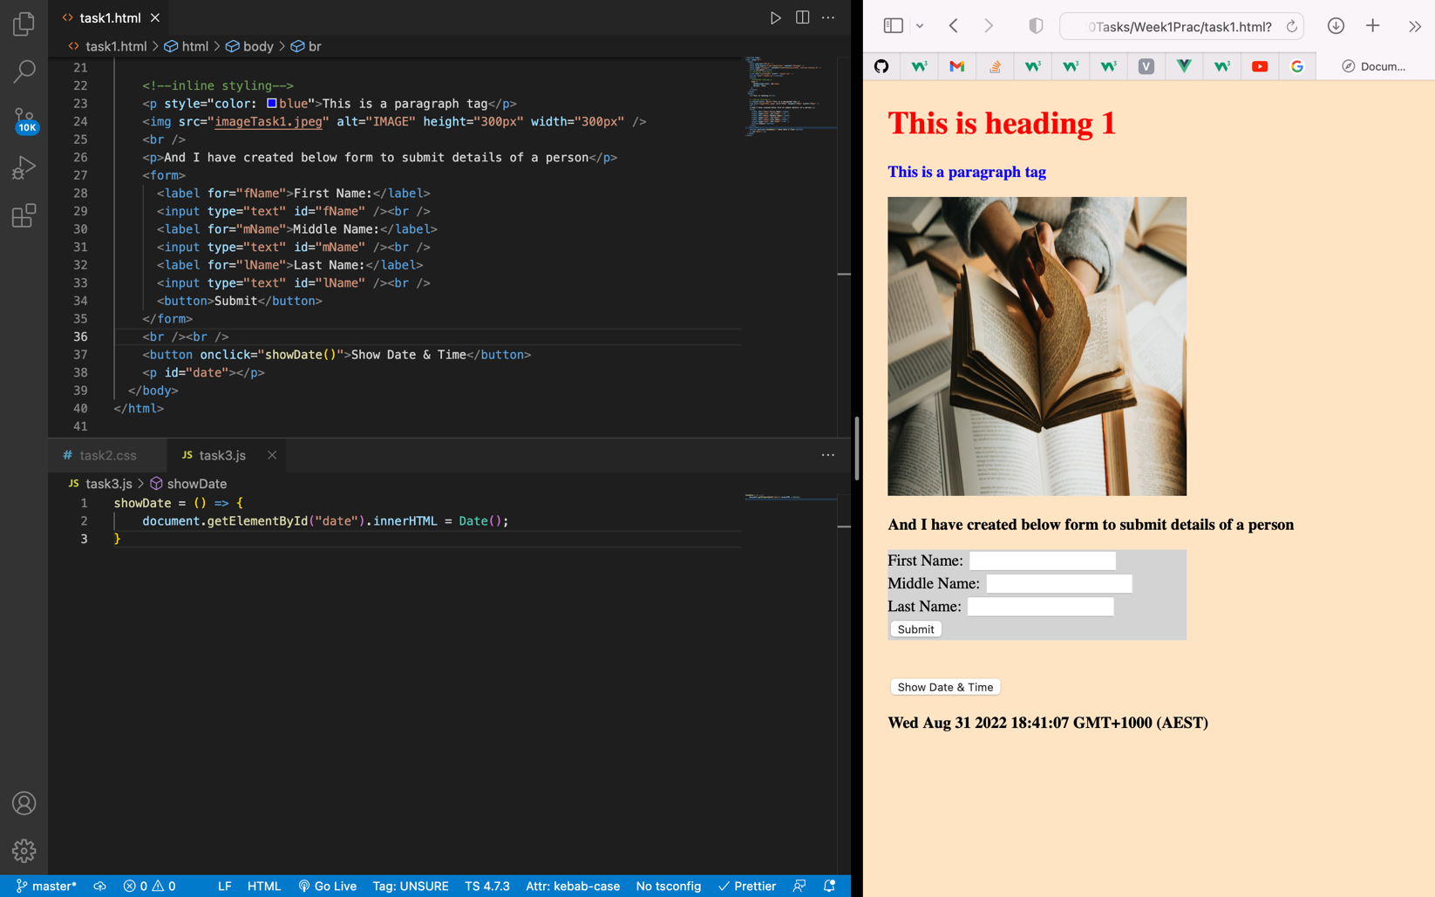

**Pass Task 4 – How to use Git and GitHub**

Reflection:

After completion of this task I was able to create a GitHub account. In GitHub account I was able to create an repository and add my project files including the code to that repository.

Below is the screenshot of the page after a repository is created.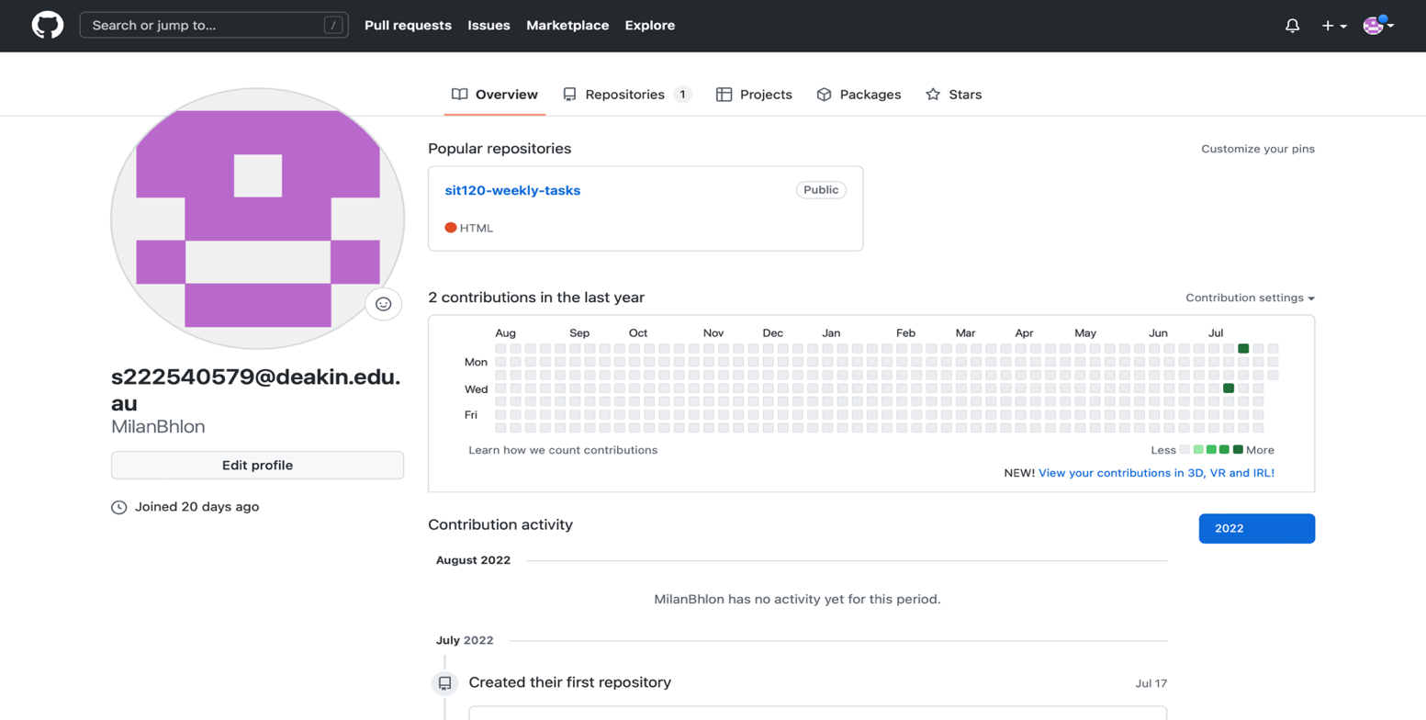

**Credit Task 5 – Vue.js Framework (homework)**

Reflection:

After completion of this task I learned to create a simple Vue app. I understood about the concept of Vue instance and how to inject it to the html file.

Below is a simple Vue to-do app.

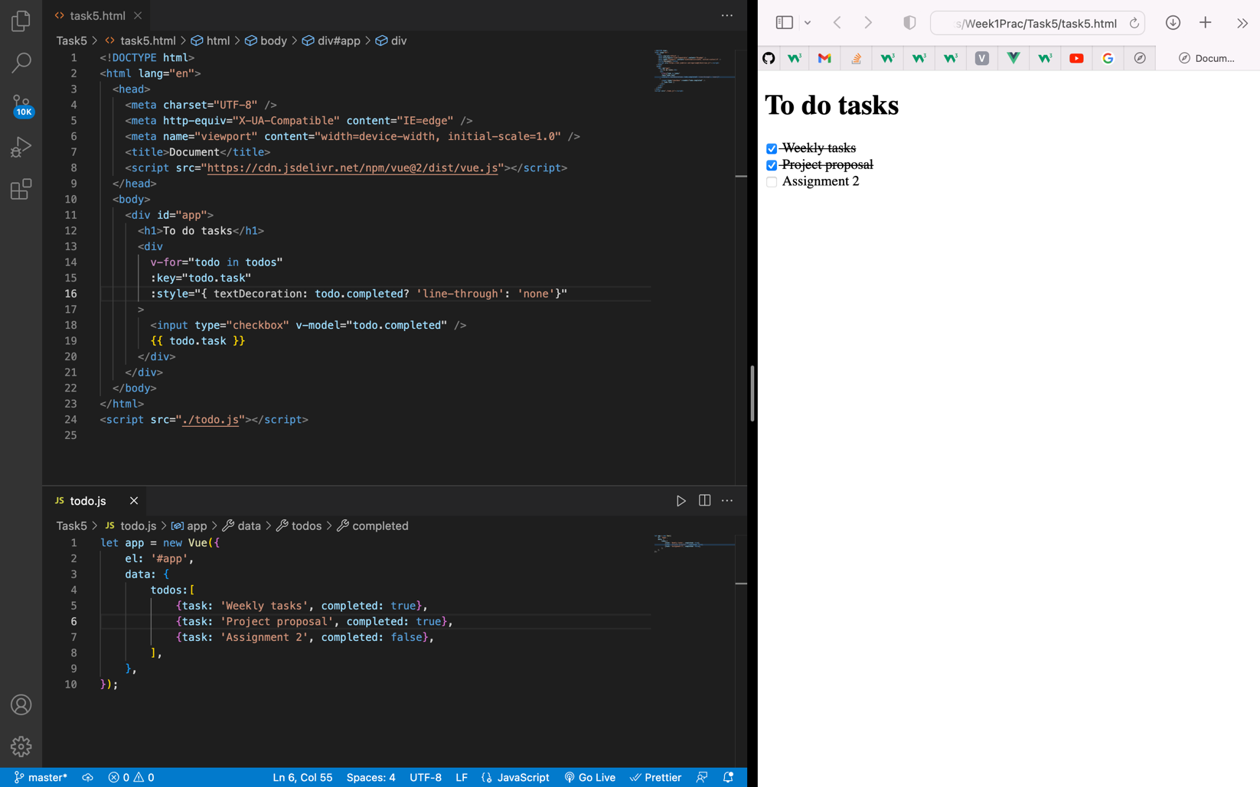

SIT120 – WEEK 2

**Overview:**

Learning Reflections:

This week we learned the concept of responsive web design which helps to design a website to display the contents in mobile devices without compromising its quality. This can be achieved by considering different factors such as screen size, device type etc.

**List of Tasks:  
Pass Task 1 – Understand about responsive web Pages and apps**

* Responsive web design is a way of designing web pages in such a way where it responds to user needs depending on the devices they’re using. Responsive web pages change the layout based on the size & capabilities of the device. For example, on an iPhone, users would see content shown in a single column view; a tablet might show the same content in two columns.

Responsive web design is important because it helps us to design sites which can adapt to different mobile devices which are often constrained by display size & additional features today or in future for users’ better experience.

As you can see in the below images that the site is responsive to different devices as per their display size.

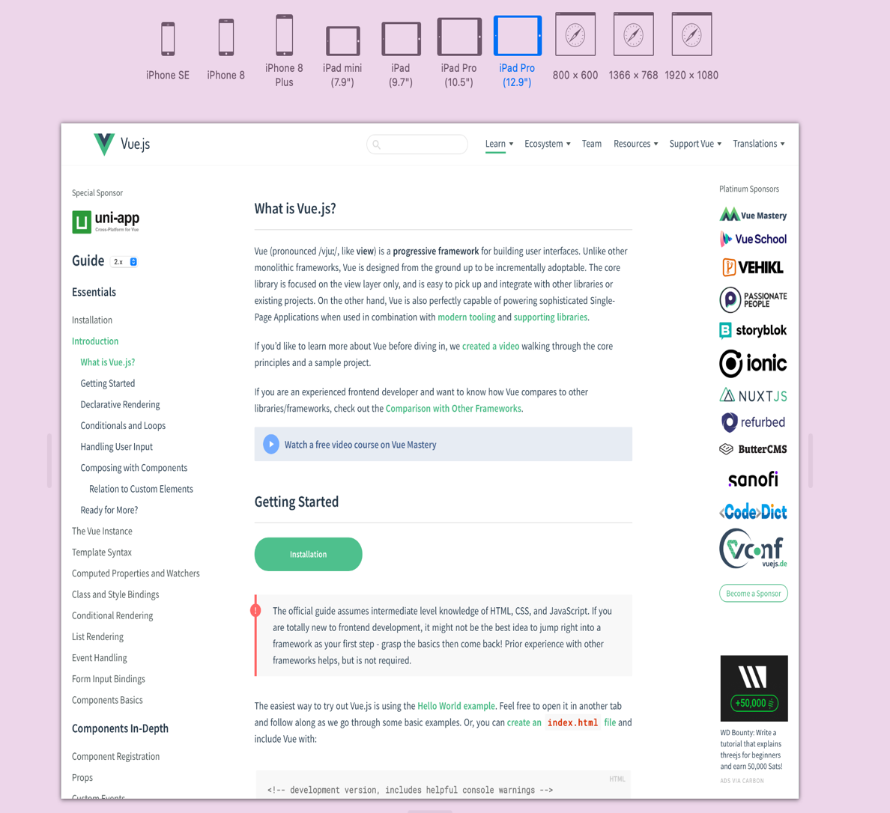

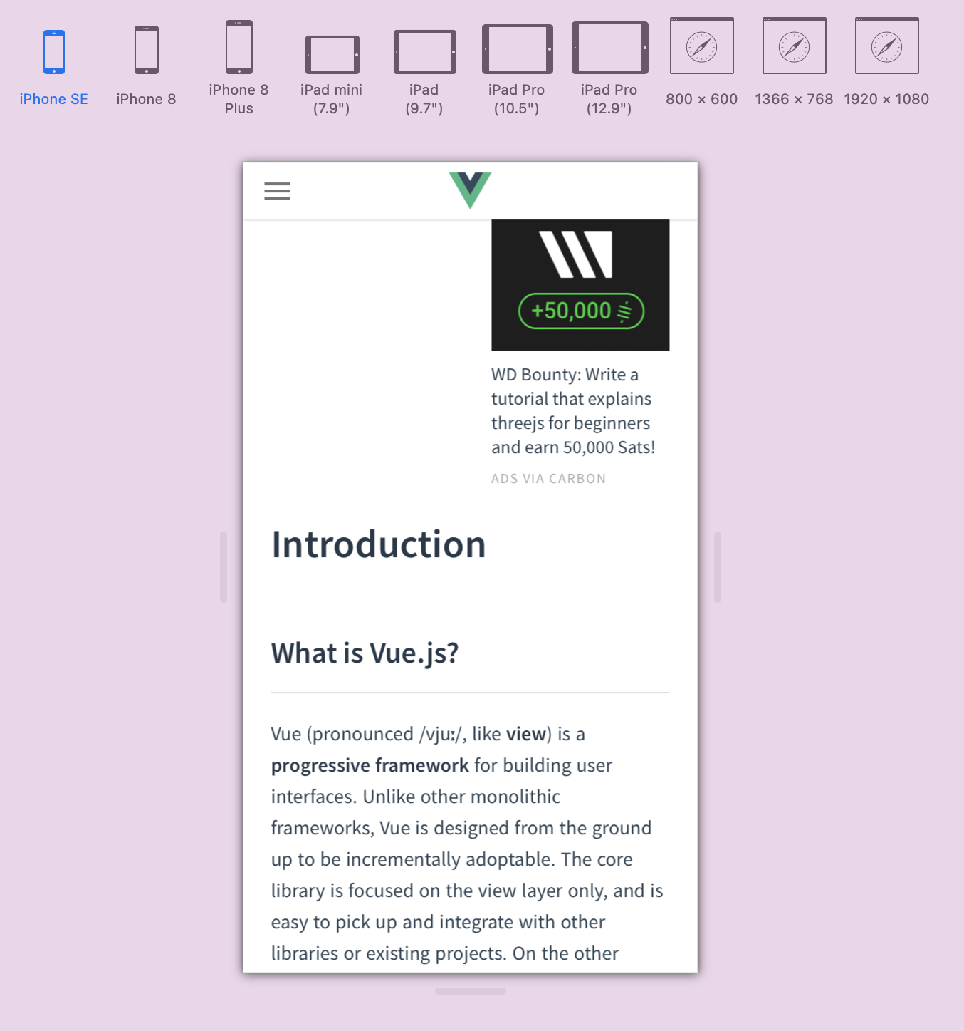

**Pass Task 2 – Understanding how responsive web design can be implemented using CSS Instruction:**

**CSS media queries for responsive web design implementation**

Sometimes more extensive changes are needed to support layout in different screen sizes. Media queries become useful in this kind of scenario.

Media queries are simple filters that can be applied to CSS styles which make it easy to change styles based on the types of devices rendering the content, or the features of that device. For example, width, height, orientation, ability to hover, and whether the device is being used as a touchscreen.

**Screenshots**

Below screenshots shows how @medai rule can be implemented. It shows that when the device screen maximum width is <=600px, the background colour changes to light-blue and when the device screen width is >600px, the background colour changes to yellow.

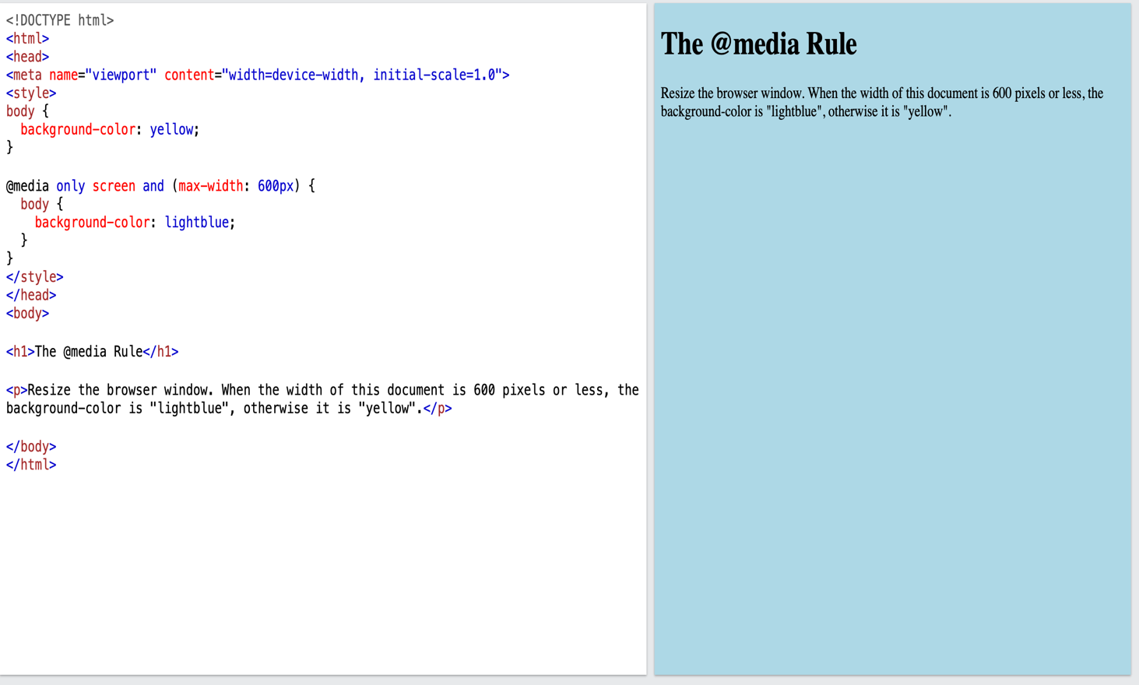

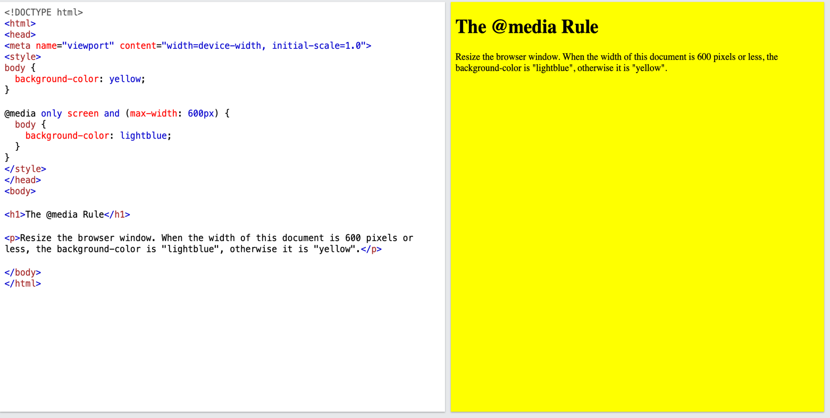

**Credit Task 3 – User stories and UI/UX design for your project**

* User stories are important because it helps to clarify the software functionality which make the development process easier. Similarly, UI/UX protype helps to demonstrate user stories in an effective graphical manner and helps to figure out any challenges before starting the UI tasks.

**User Stories:**

1. **As a member, I want to create either a public or private profile**
   1. Members should be able to enter their personal details
   2. Verify the details & complete the signup process
   3. Once the member is logged into their profile, there should be an option to make the profile public or private
   4. Member should be able to update more details about their health & fitness once they are logged in to maintain proper track record of their fitness journey
   5. There should be an option to upload profile picture
   6. There should be an option to upload recent & past pictures of the member is fitness gallery to create a visual track record
2. **As a member, I want to update my profile**
   1. Member should be able to update their profile in profile setting page
   2. Should be able to change profile picture
   3. Should be able to add or delete pictures from the fitness gallery
   4. Should be able to change their profile type either from private to public mode or vice-versa
   5. They should be able to update their new or change old details

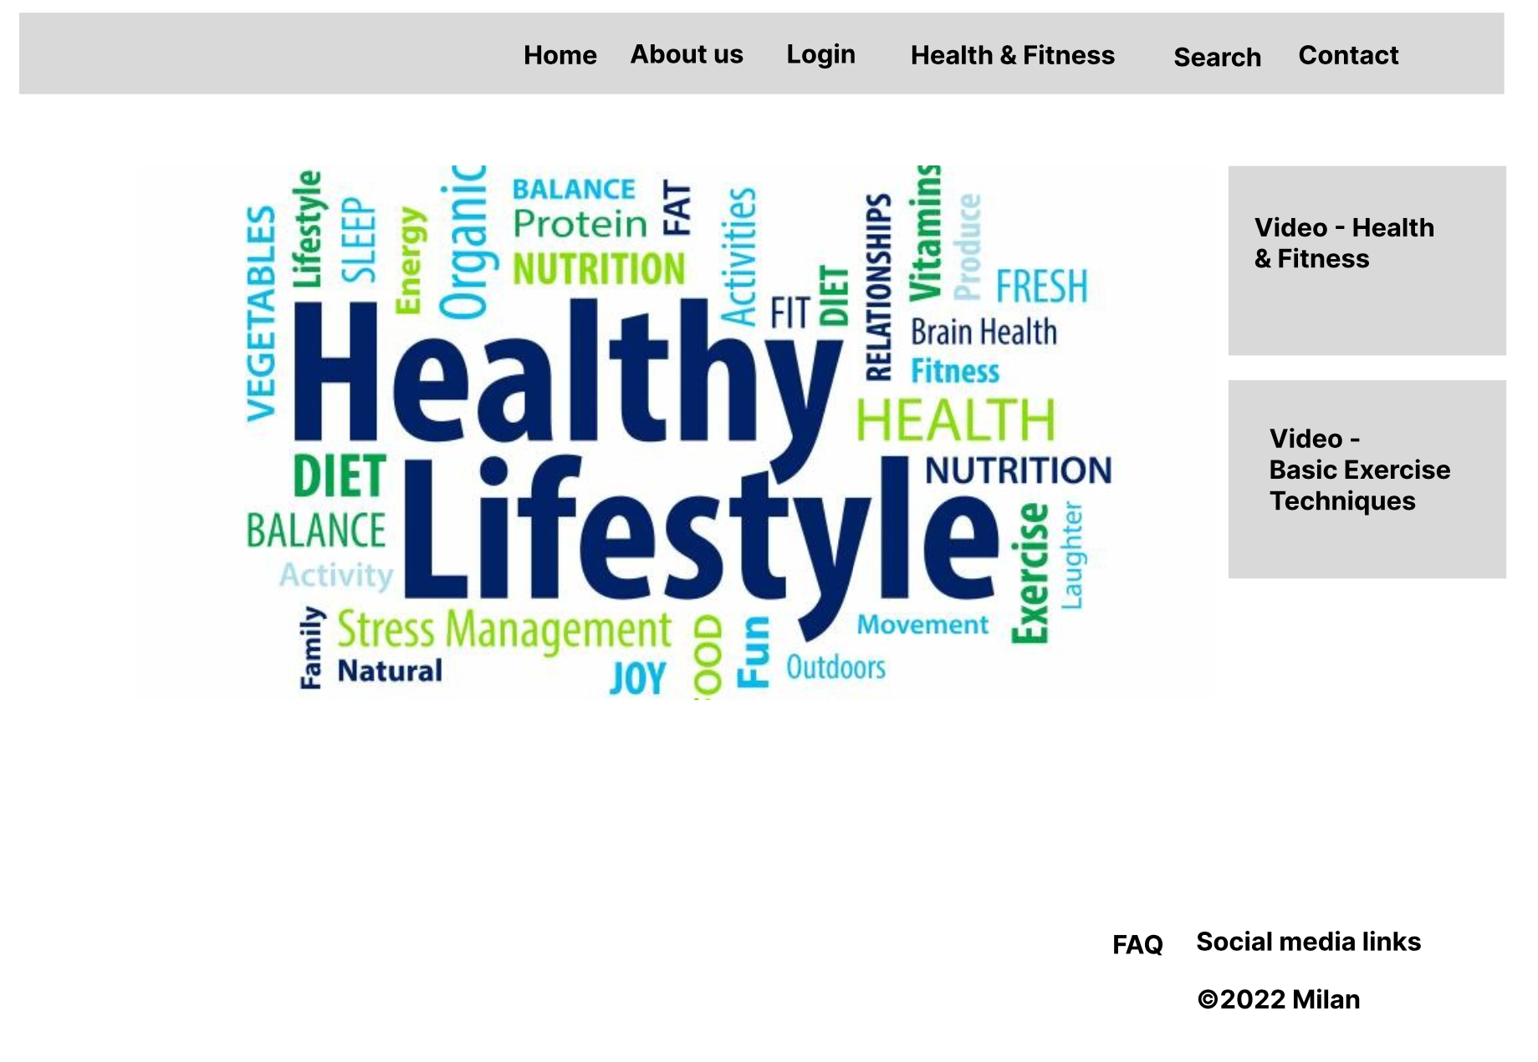Below 3 images are the UX/UI design for my project

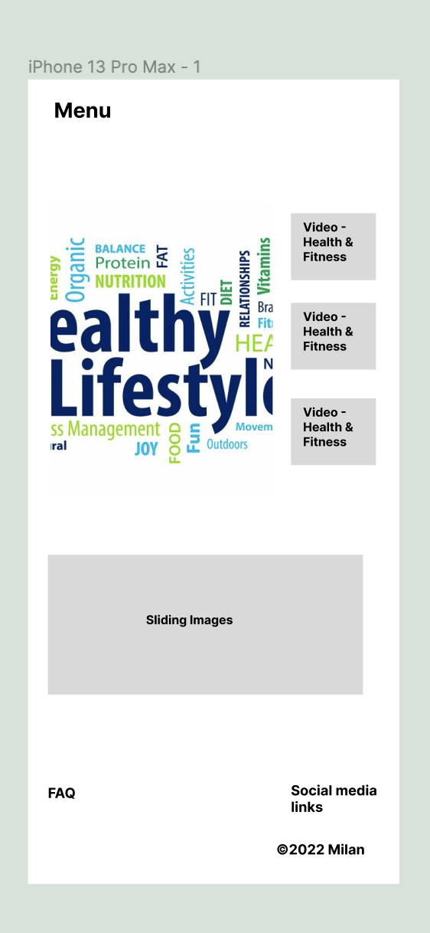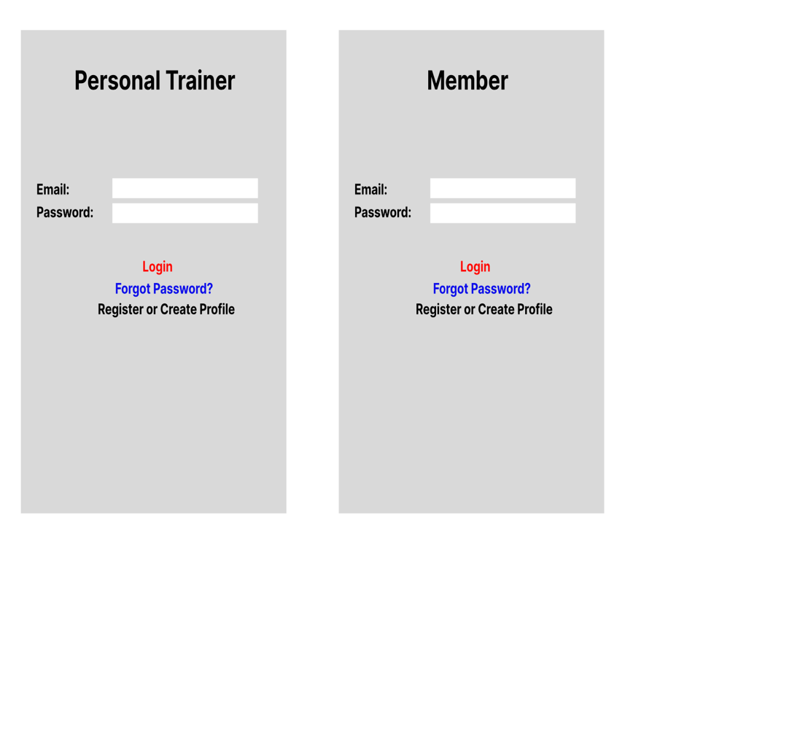

**Distinction Task 4 – Use graphics, media and APIs (Homework)**

Reflection:

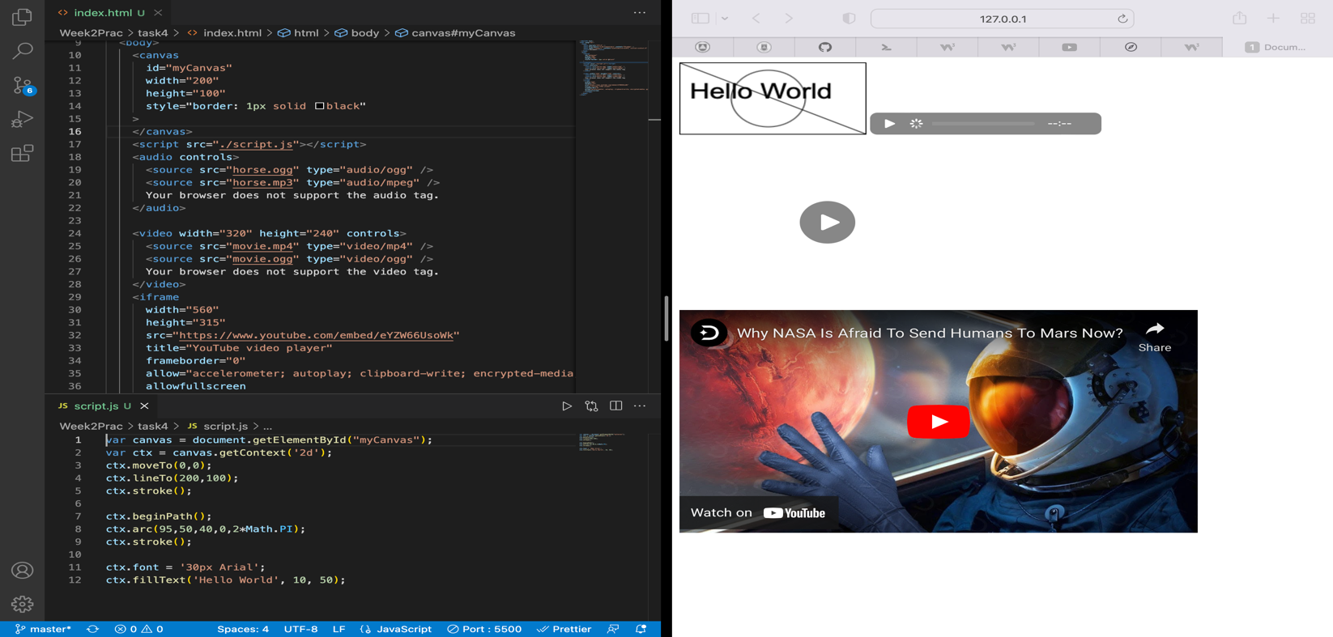This task helped to understand about how to implement graphics using JS in html and some media tags in html such as video, audio etc.

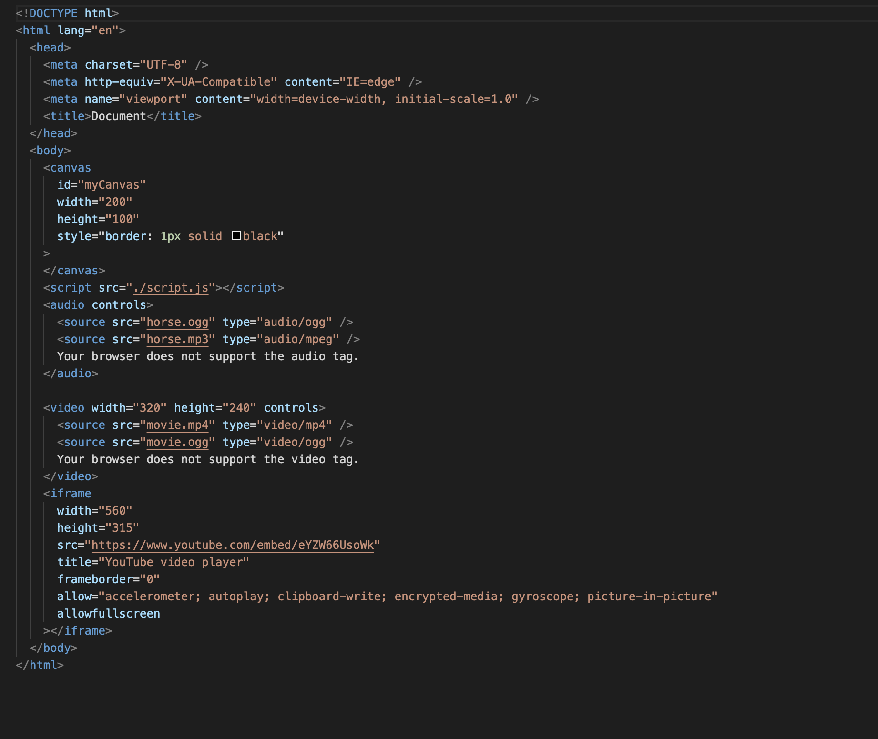

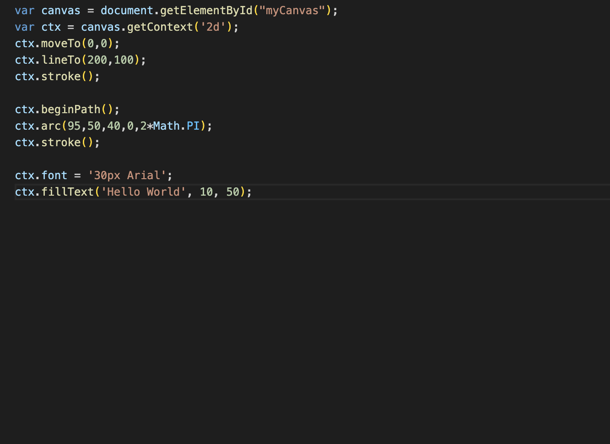

SIT120 - Introduction to Responsive Web Apps Week 3: JavaScript Functions

**List of Tasks:  
Pass Task 1 – JavaScript String Methods**

Reflection:

This task helped me to understand about different JavaScript string methods that can be used to manipulate the string value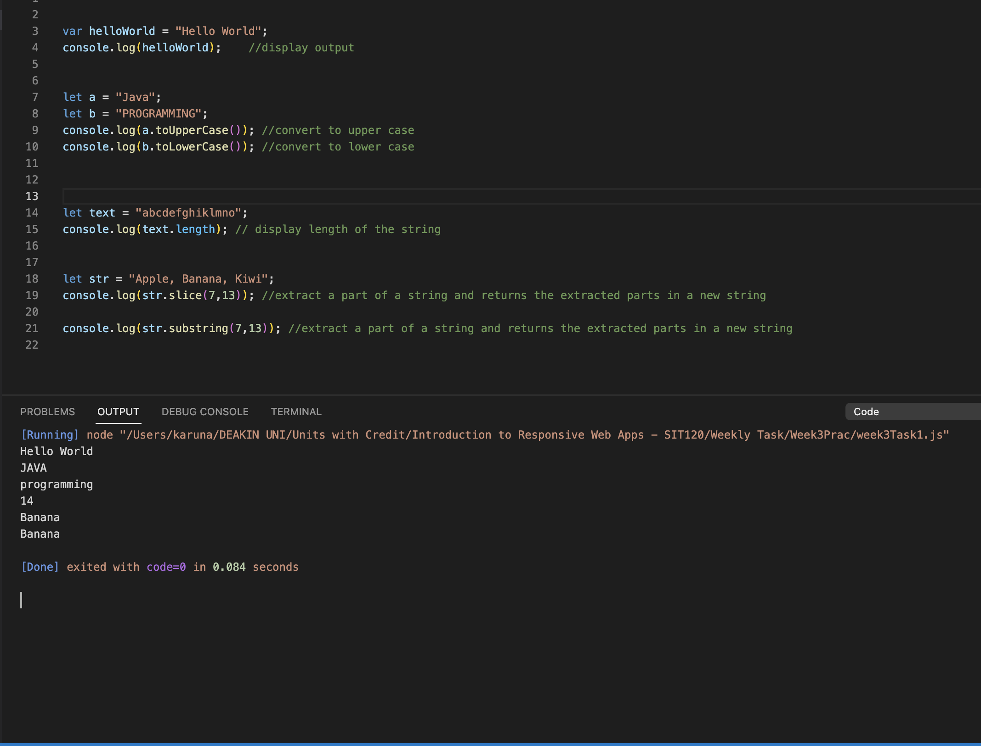s.

**Pass Task 2 – JavaScript Number, Number Methods and Array Methods**

Reflection: This task helps me to understand about different number and array methods and implement them to manipulate the string and number arrays.

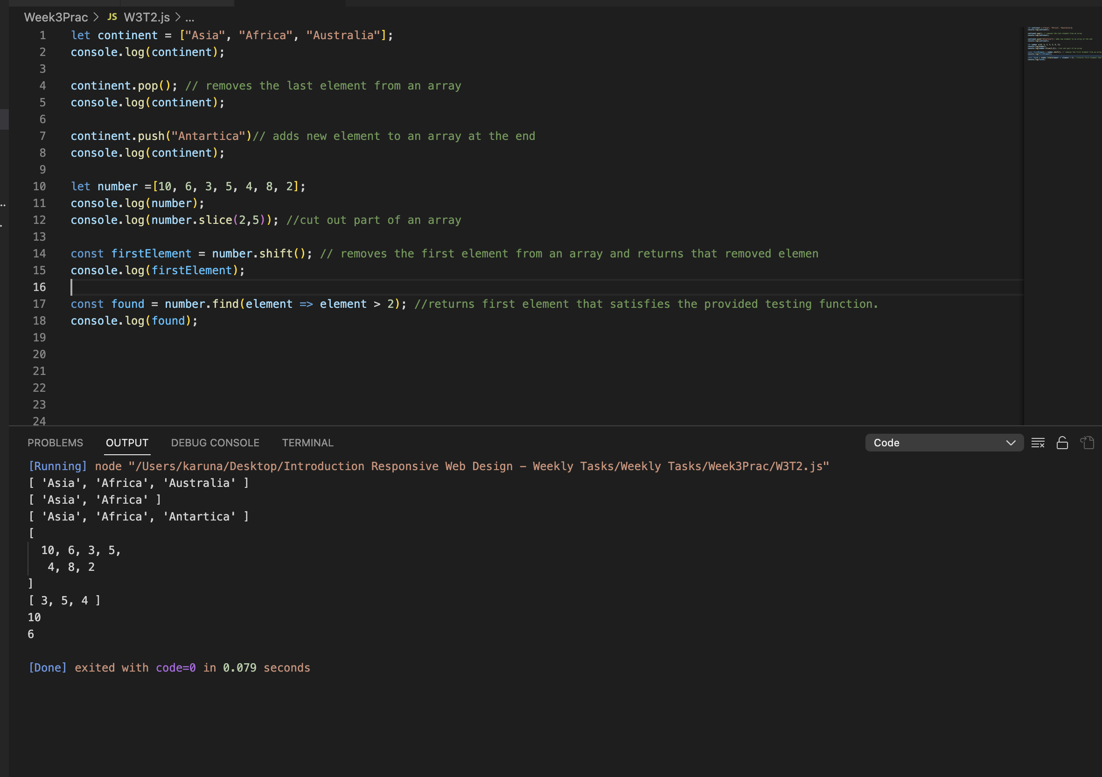

**Credit Task 3 – JavaScript Date API**

Reflection:

This task helped me to understand how to create a date object using new Date () constructor and once a date object is created, different methods allow to operate on it as shown in the picture below.

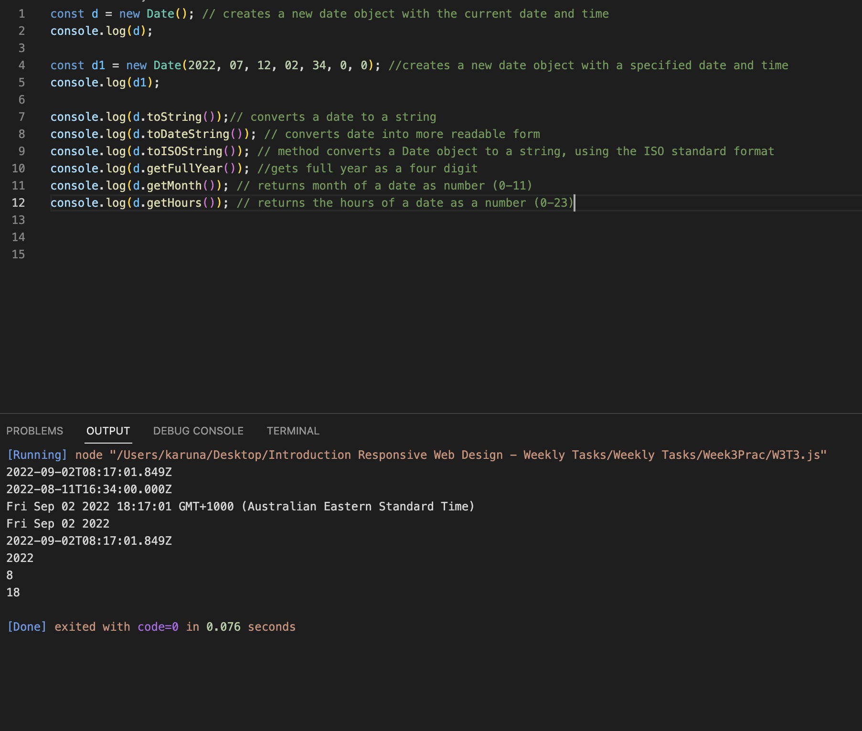

SIT120 - Introduction to Responsive Web Apps Week 4: Vue.js Framework

**List of Tasks:  
Pass Task 1 – Create basic Vue application**

Reflection:

After completion of this task, I can understand and implement how to link Vue instance with html single element and control it.

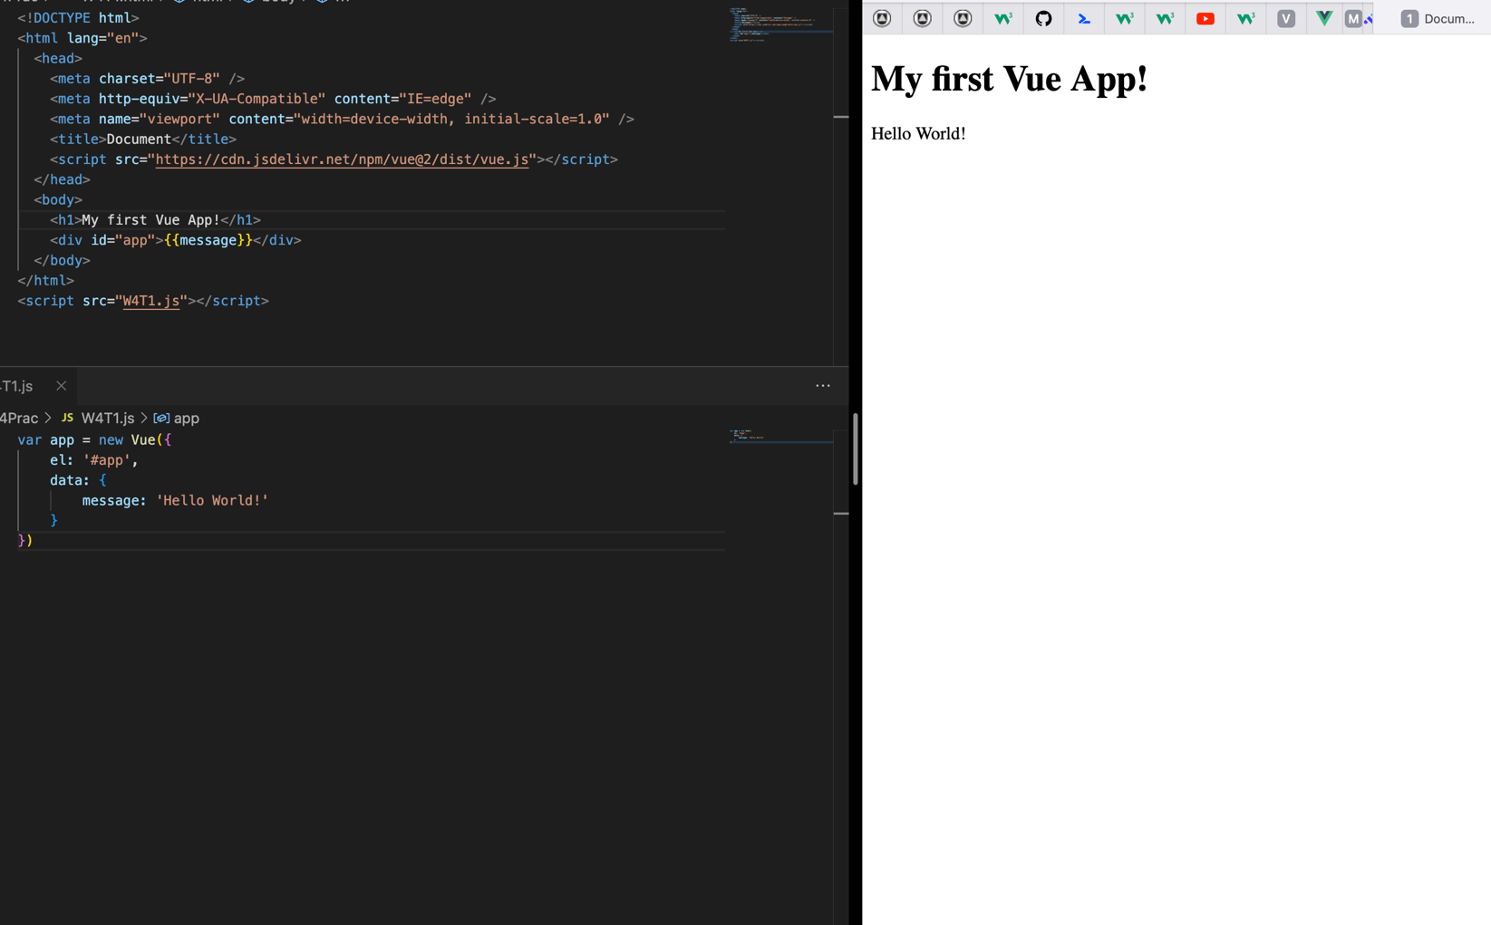

**Credit Task 2 – Conditionals and Loops**

Reflection:

This task helped me to learn about conditional rendering and loops using Vue. I learned that directives are prefixed with v- to indicate that they are special attributes provided by Vue which apply special reactive behaviour to the rendered DOM.

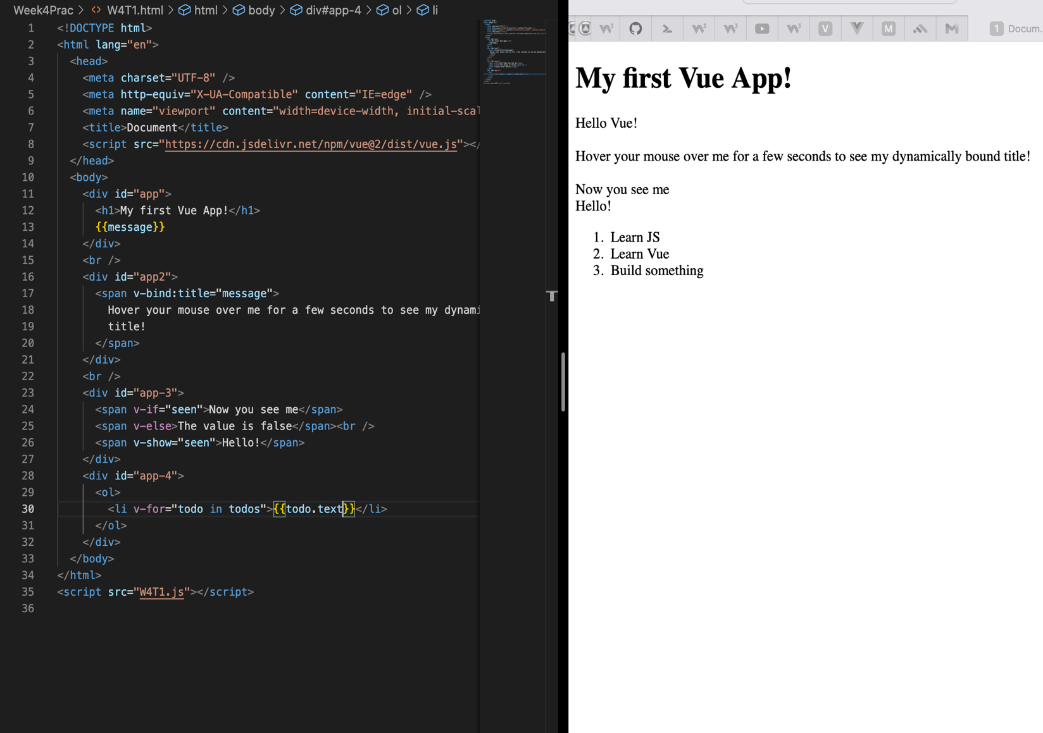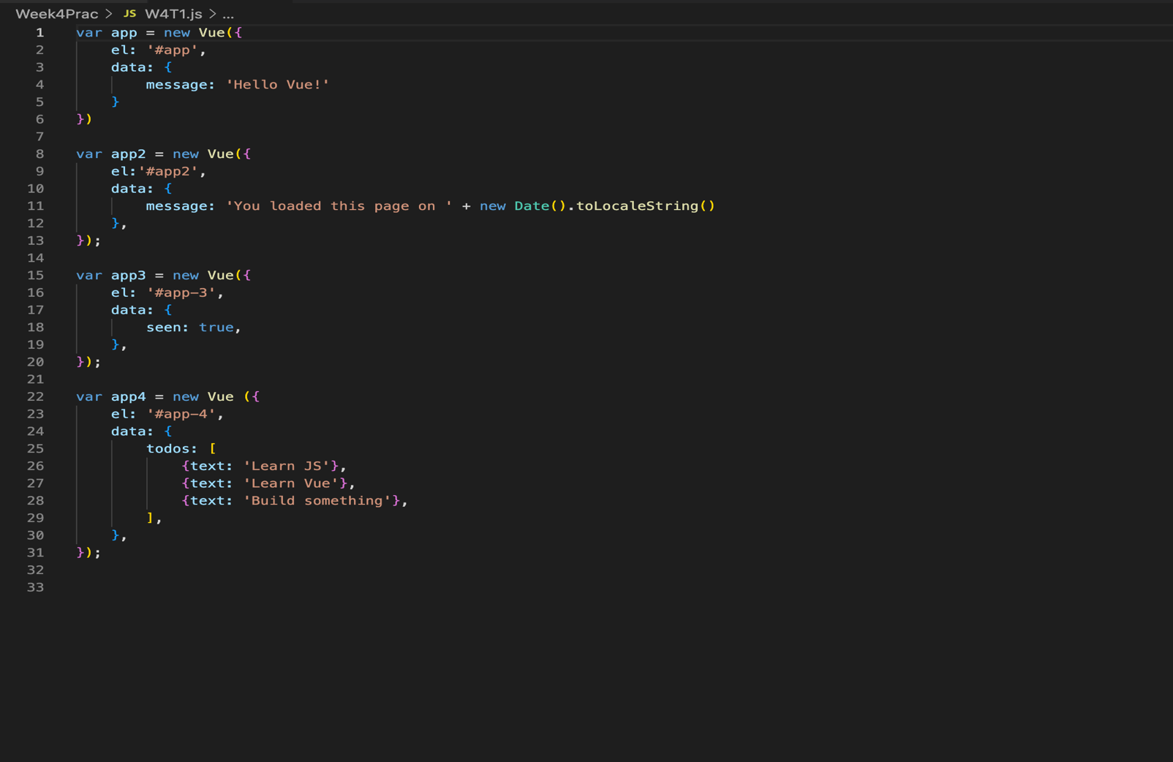

SIT120 - Introduction to Responsive Web Apps Week 5: Vue.js Framework

**Overview:**

This week, you will focus on gaining a better understanding of the Vue.js Framework and its different components and play with different examples.  
**NOTE: This week’s tasks are all about learning only, you do not need to push anything to GitHub. Just 1-2 sentences reflections needed for each task.**

**List of Tasks:  
Pass Task 1 – Components Basics**

Reflection:

After completion of this task, I got to know that Vue components is a set of independent code which can be registered either locally or globally and use it as many times as required in the web development process.

**Credit Task 2 – Understanding Handling User Input**

Reflection:

After completion of this task I was able to understand how to handle use input data. In this task, I learned about V-model directive which is used to create two-way data bindings.

V-model internally uses different properties and emits different events for different input elements:

* Text and textarea elements use **value** property and **input** event
* Checkboxes and radio buttons use **checked** property and **change** event
* Select field use **value** as a prop and **change** as an event

**Distinction Task 3 – Learning Component Registration**

Reflection:

* There’re two types of component registration: local and global
* When registering a component, it will always be given a name.
* The component’s name is the first argument of Vue.component

**Global registration:**

Syntax:

Vue.component (‘component-name’, {

// …. Options …..

})

These components are globally registered, and they can be used in the template of any root Vue instance created after registration.

Example: Vue.componet(‘component-a’, { ……. })

Vue.compoent(‘component-b’, { ……. })

New Vue ({ el: ‘#app’ })

This even applies to all subcomponents, meaning all two of these components will also be available inside each other.

**Local Registration:**

Global registration often isn’t quite ideal. In these cases, we can define our components as plain JavaScript objects:

Example: var ComponentA = { …. }

var ComponentB = { …. }

var ComponentC = { …. }

Then define the components to use in components option:

new Vue({

el: '#app',

components: {

'component-a': ComponentA,

'component-b': ComponentB

}

})

Locally registered components are not available in subcomponents.

The following example will show how to make componentA available in component,

var ComponentA = { /* ... */ }

var ComponentB = {

components: {

'component-a': ComponentA

},

// ...

}

**Distinction Task 4 – Learning Props, Events and Slots Instruction:**

Reflection:

After completion of this task, I was able to understand how props can be created in Vue component and use it to pass data from a parent component to its children component.

Then I learned about custom events which can directly access parent component and trigger the methods in parent component.

Similarly, I also learned the concept of slots to use it as a template on different use cases.

SIT120 - Introduction to Responsive Web Apps Week 6: Vue.js Framework (Handling User Inputs)

**Overview:**

**List of Tasks:  
Pass Task 1 – Using *v-model* directive for Handling User Input (Form Input Bindings) Instruction**:

Reflection:

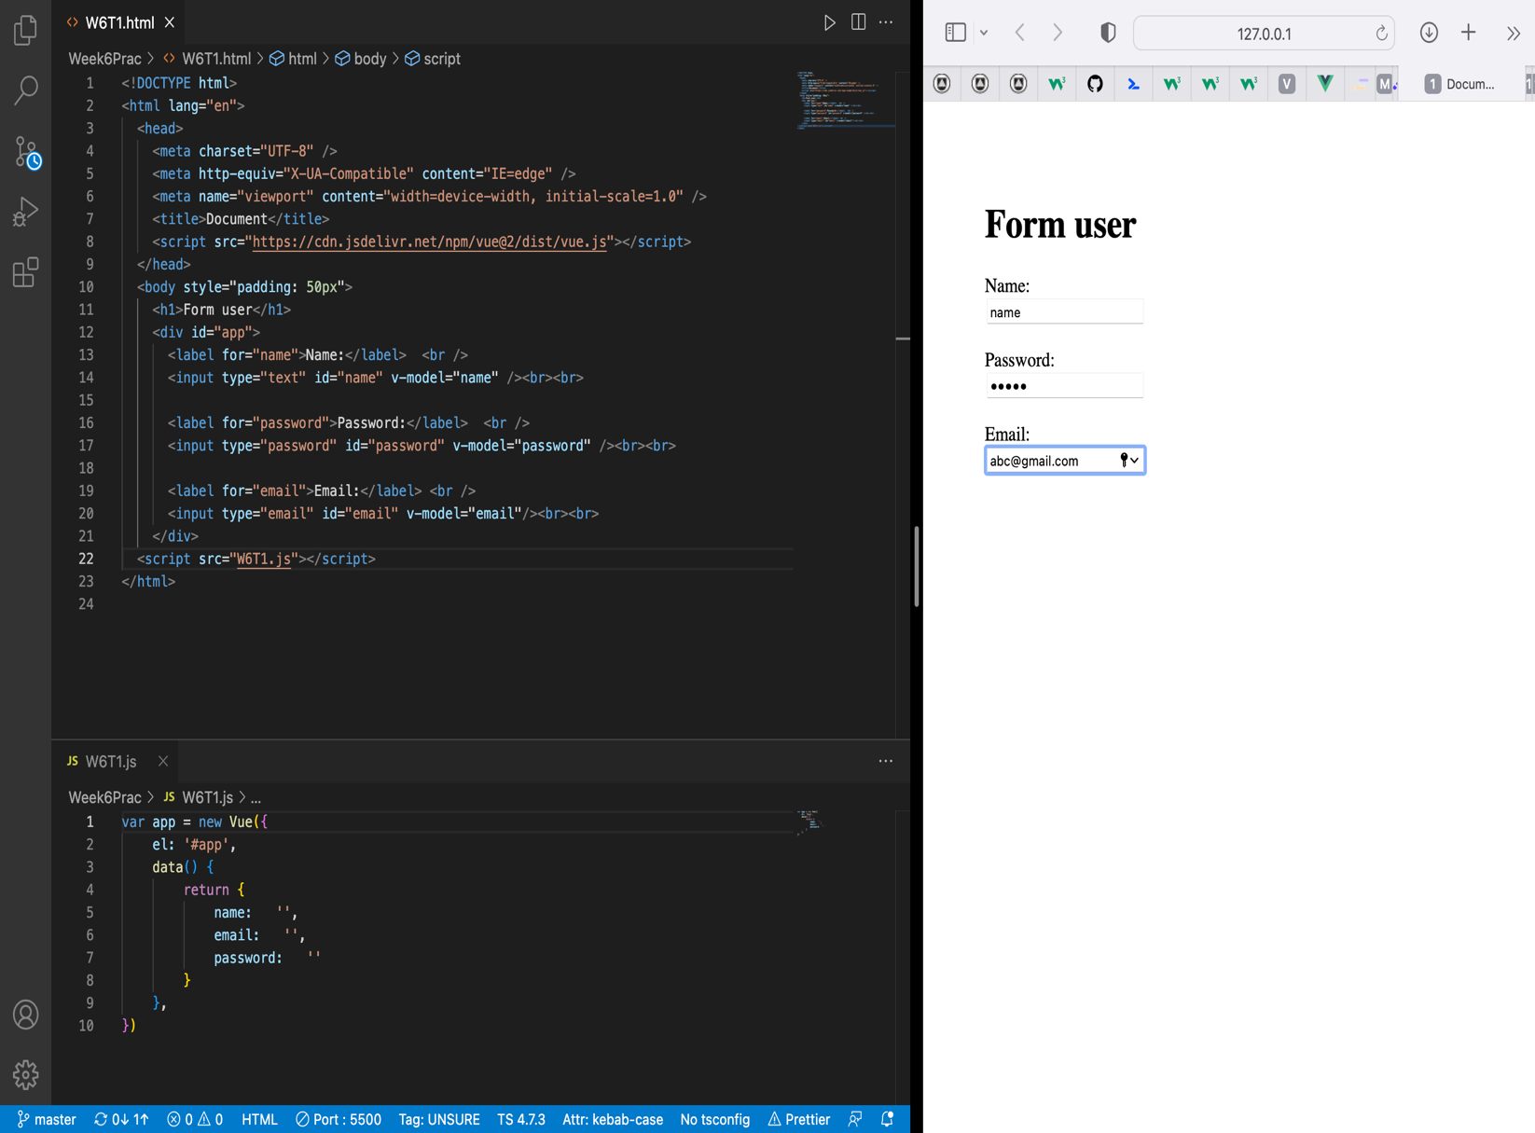V-model directive is implemented to perform two-way binding and handle user inputs.

**Pass Task 2 – Checkbox in your project**

Reflection:

With the help of this task, I was able to manipulate different checkbox options via Vue instance implementing two-way binding (v-model).

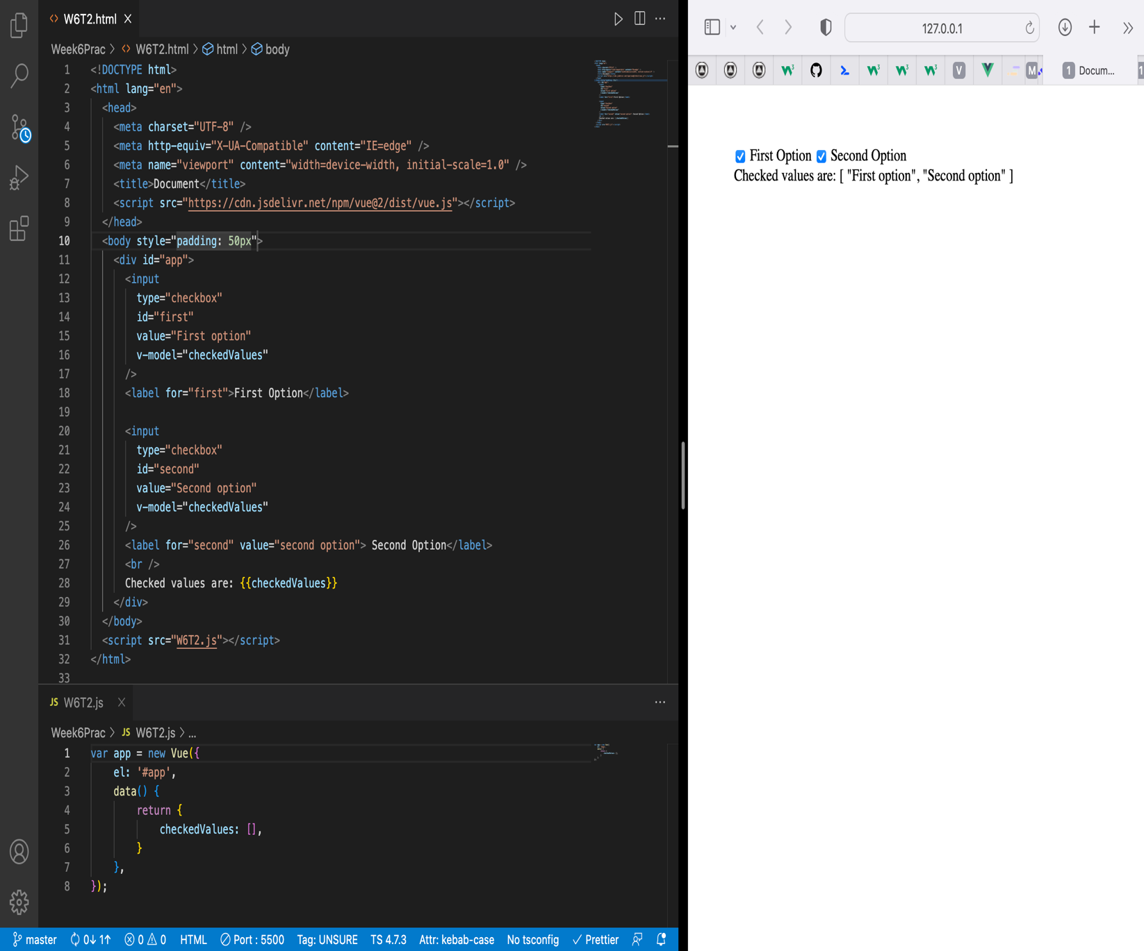

**Credit Task 3 – Dynamic options rendering using v-for**

Reflection:

This task helped me to implement v-for directive for dynamic options rendering as shown in the image below.

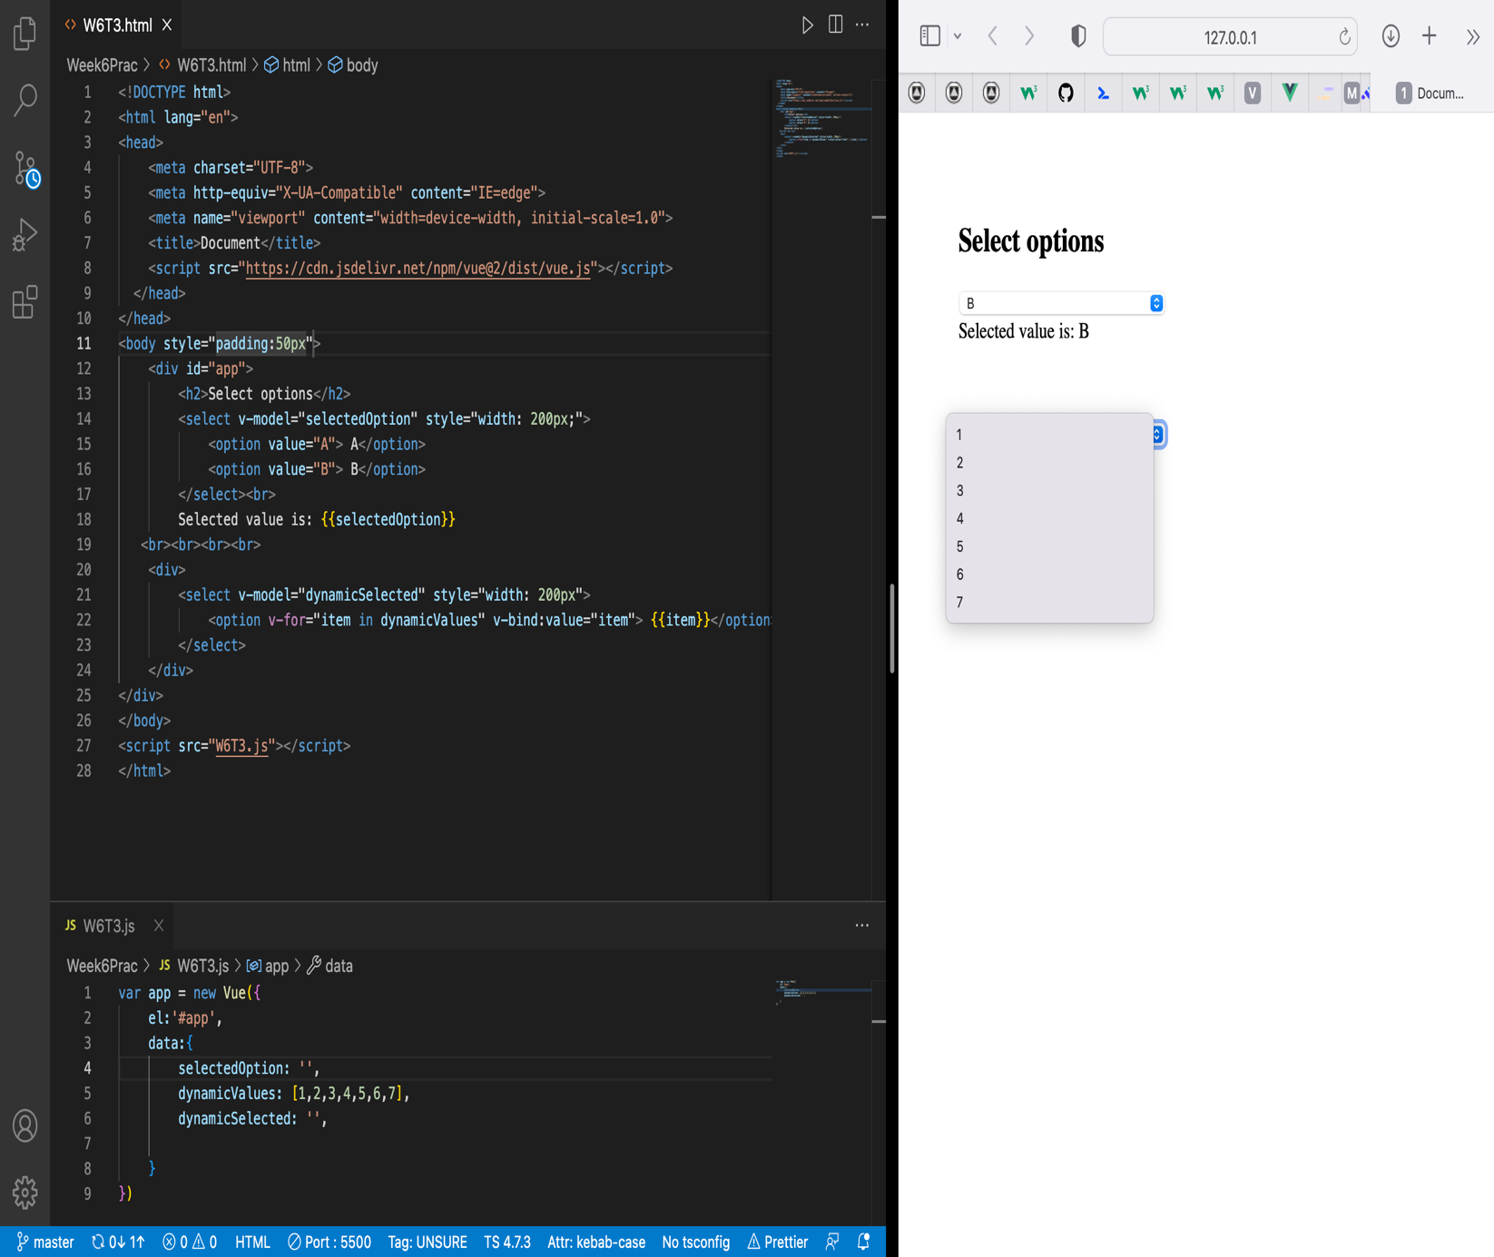

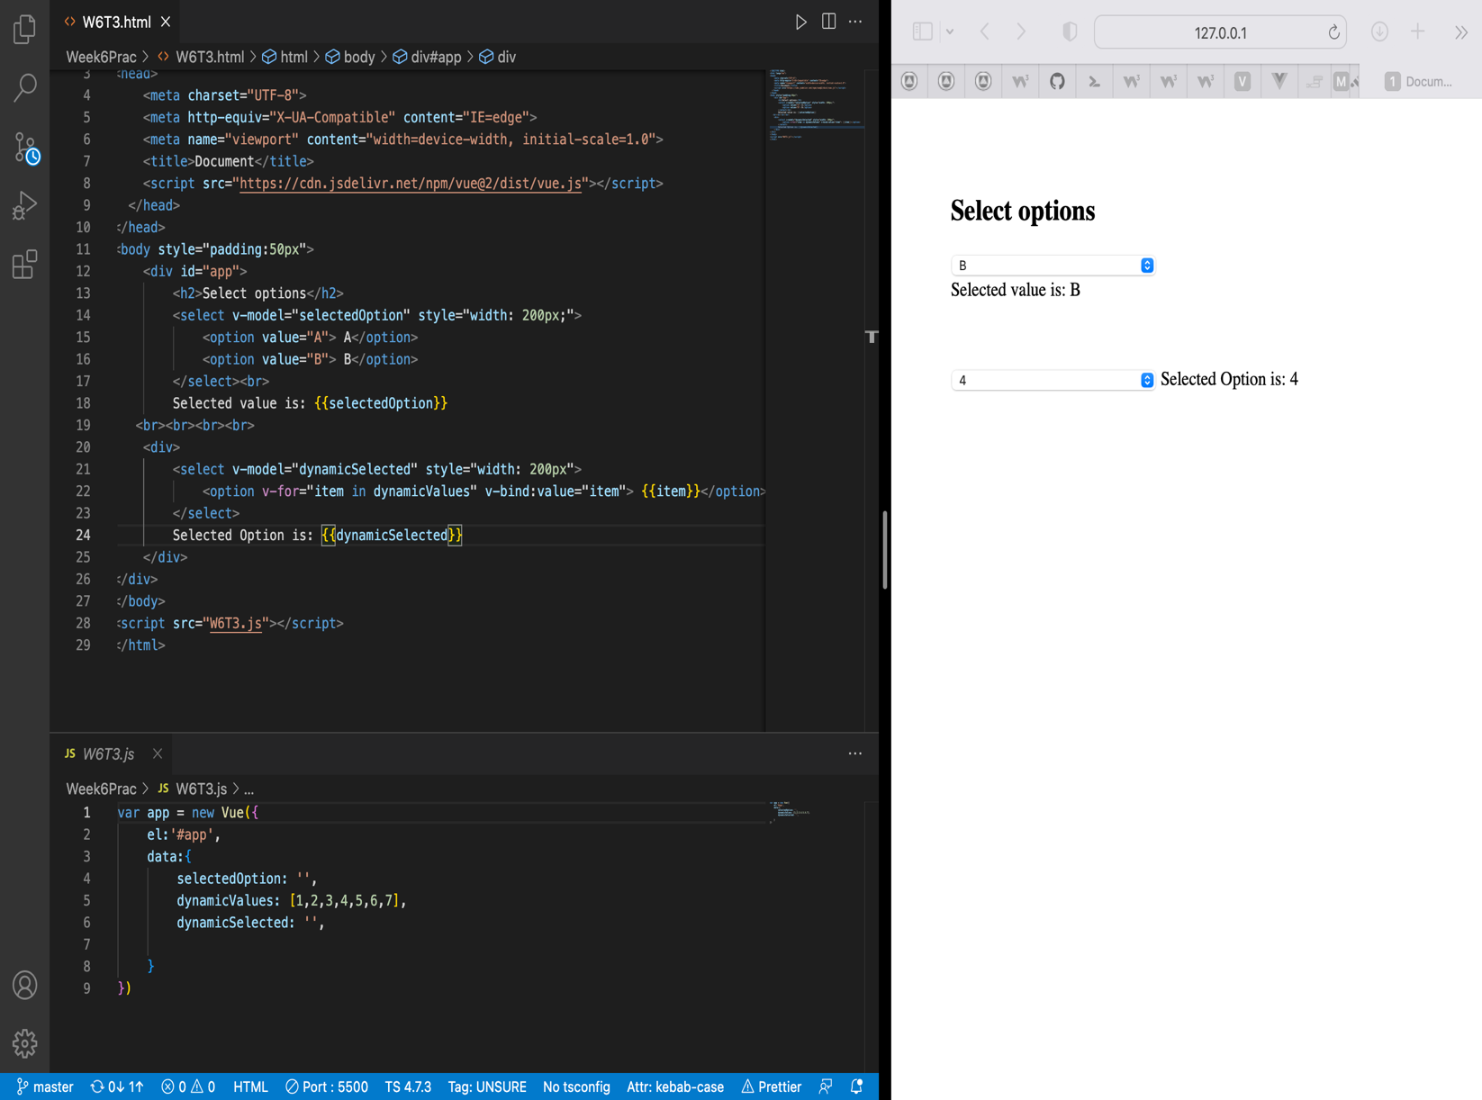

SIT120 - Introduction to Responsive Web Apps Week 7: Registration, Props, Custom Events, Dynamic/Async

**List of Tasks:  
Pass Task 1 – Component Registration**

Reflection:

After completion of this task, I learned how to register local and global components and use them when necessary.

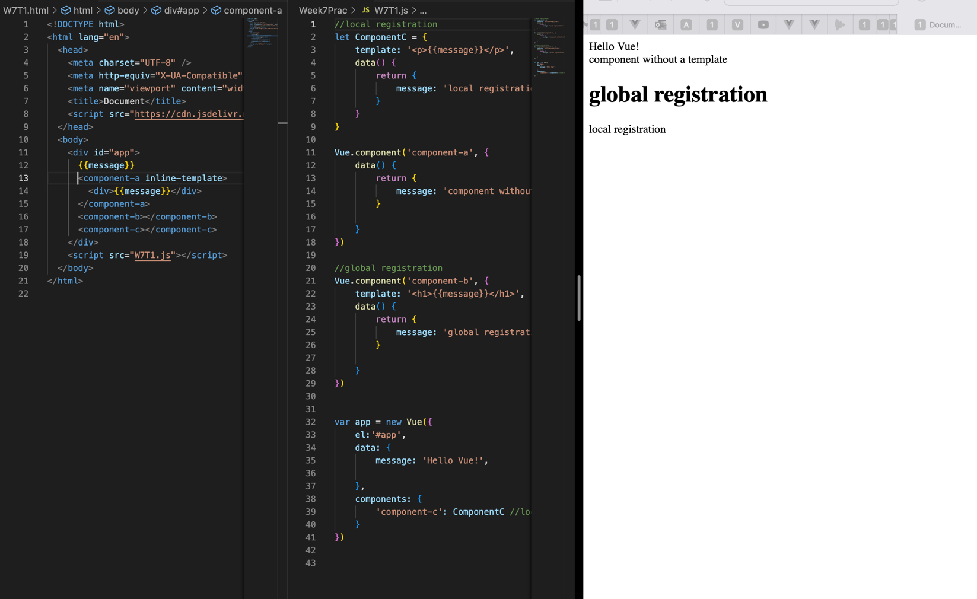

**Credit Task 2 – Coding Props**

Reflection:

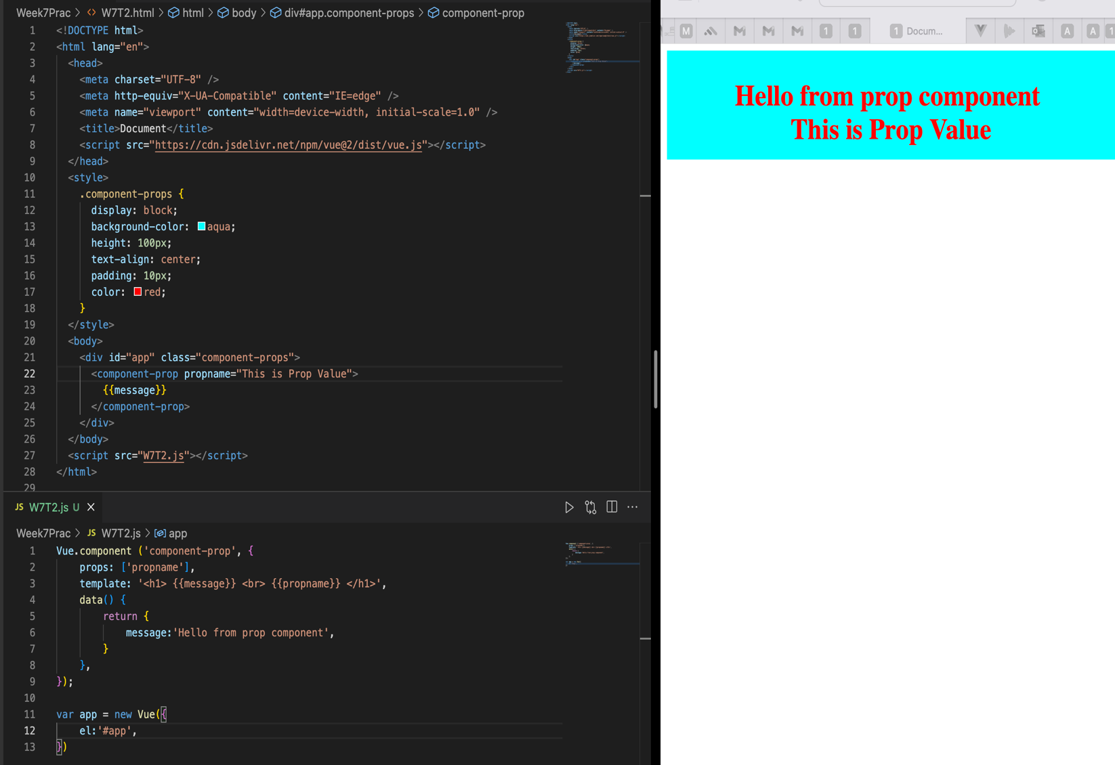This task helped me to understand about the concept of prop and how it can be implemented in Vue component where we can either statically or dynamically passed data from parent to child component.

**Distinction Task 3 – Custom Events**

Reflection:

After completion of this task, I was able to trigger events in parent component via the event from child component.

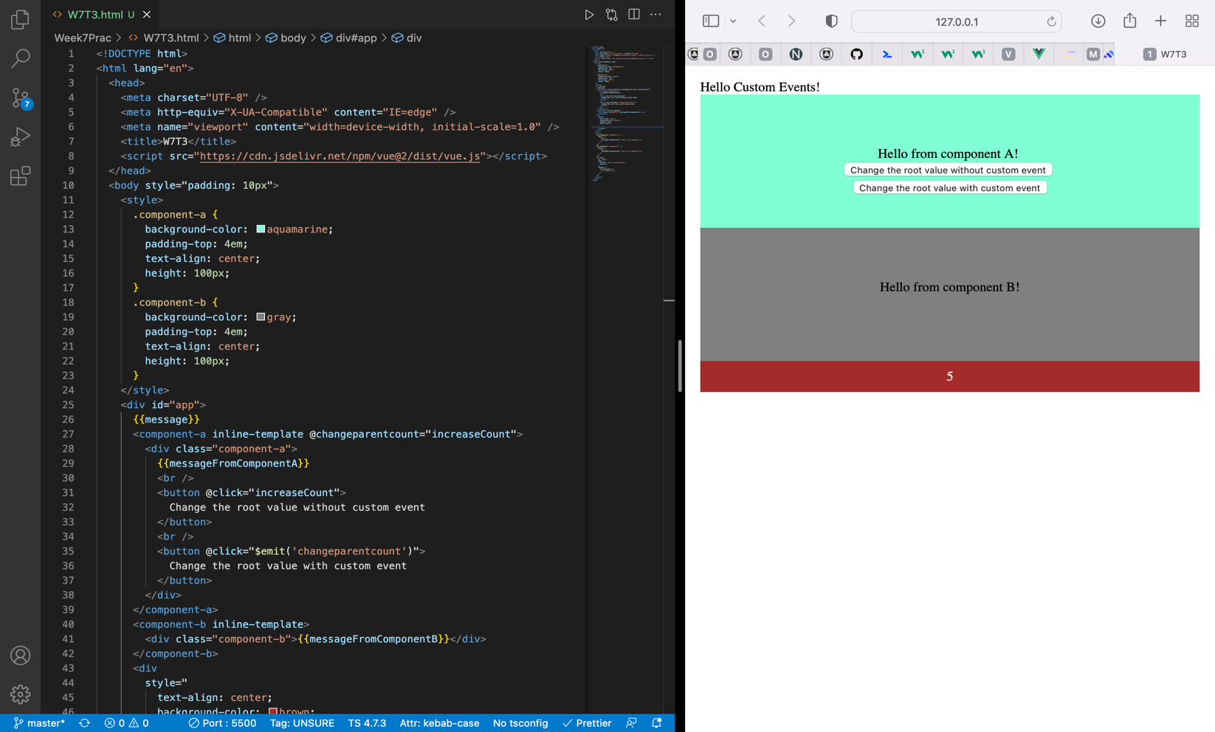

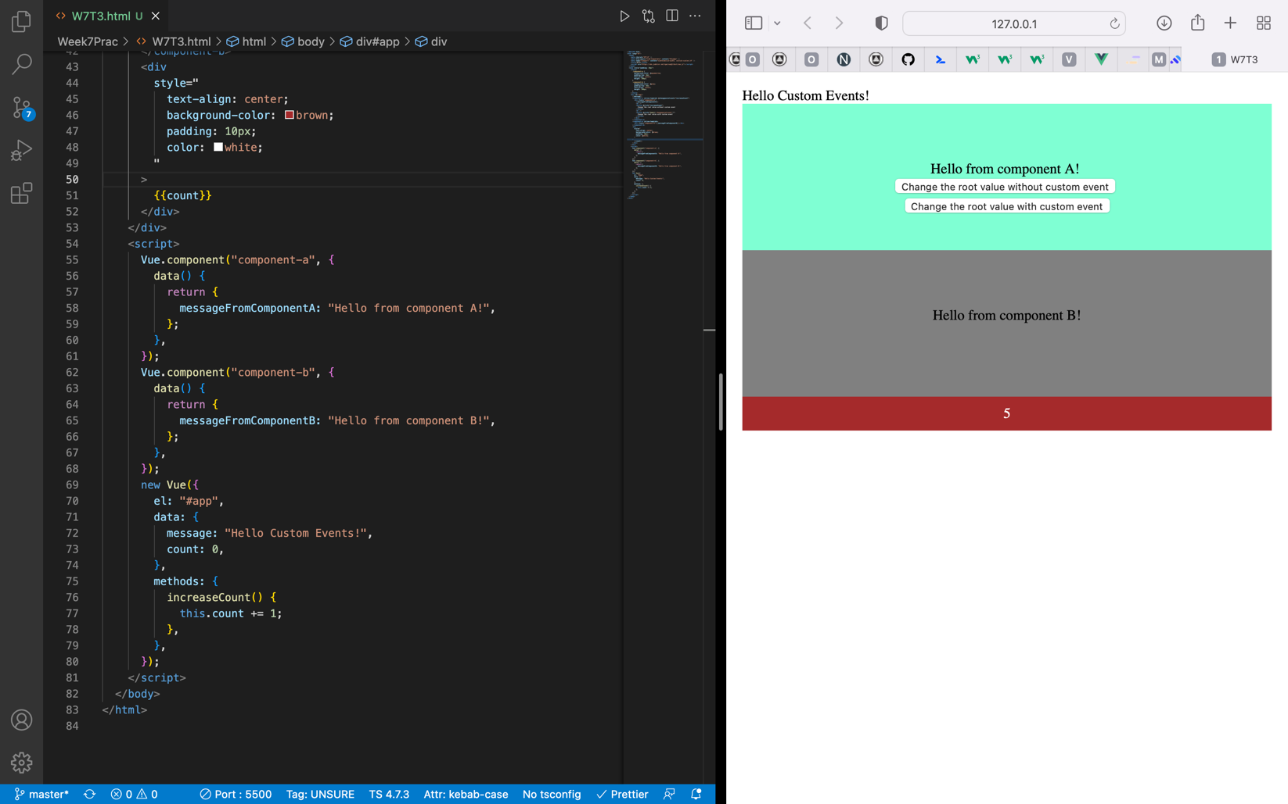

**Distinction Task 4 – Vue Slots - coding Named Slots**

Reflection:

This task helped me to understand the concept of Vue slots with the help of which we can use different html elements in same component & pass them directly instead of data.

